List of experiments in computer networks

CSA0726

NAME: gokulnath.p.

REG NO.192121156L

Experiment no:2

Configuration of star topologies using packet tracer

### 

### AIM:

To establish a star topologies usin**g cicsco** packet

### 

### REQUIREMENTS:

1. End device - They are the devices through which we can pass message from one device to another and they are interconnected.
2. Switch/Hub - Interface Between two devices.
3. Cable - Used to connect two devices.

Procedure:

**STEP** 1: select desired switch model

**STEP** 2: choose connecting cable for device connection

**STEP** 3: initiating cable connection

**STEP** 4: connection all devices to central switch

**Step5**:open desktop menu and select IP configuration setting.

**Step6**:configure IP address and subnet mask

Star topology

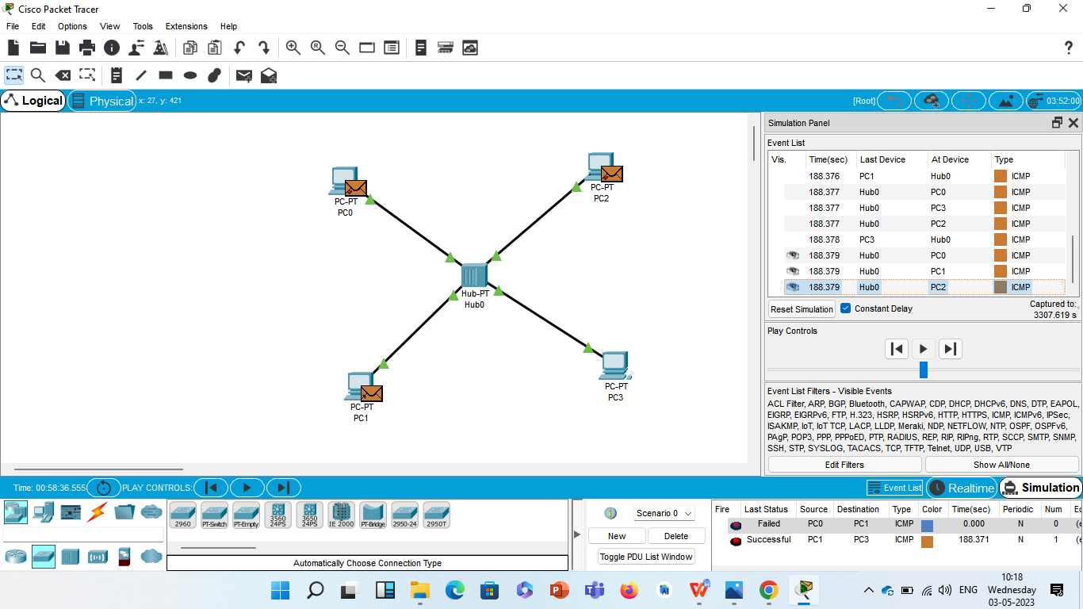

Result

Configuration of star topologies using packet tracer